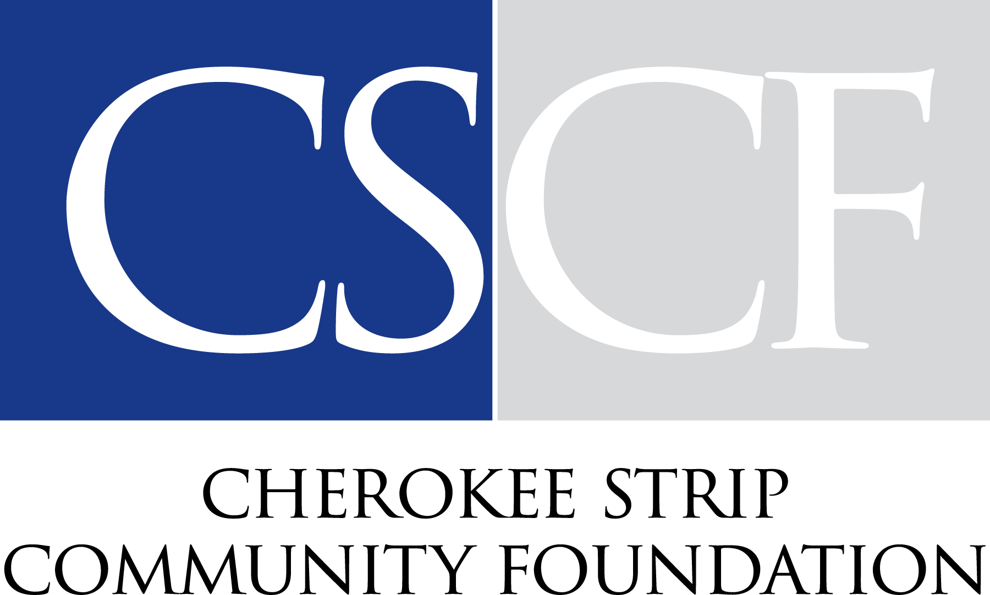
2025 CSCF Fall Competitive Grants
Funds for Northwest Oklahoma
The Cherokee Strip Community Foundation (CSCF) Board of Directors is proud to announce 13 recipients of the 2025 Fall Competitive Grant cycle. Through these two charitable funds, CSCF awarded $65,303 to nonprofit organizations serving Northwest Oklahoma and neighboring communities.
The Sisters of Mercy Fund supports organizations that promote health care and social services throughout Northwest Oklahoma. The Ralph & Win Goley Fund provides grants that promote nutrition education and help provide nourishment for individuals and families in need. Together, these funds strengthen the health and well-being of our region through strategic charitable investments.
Each year, CSCF's Grant Selection Committee reviews applications from organizations working to address important community needs. This year's funded projects improve access to health care, provide nutritious food, strengthen families, expand youth opportunities, and support vulnerable populations across Northwest Oklahoma.
The following grants were awarded:
Catholic Charities: Awarded $8,600 to provide case management, counseling, and emergency assistance in Enid.
D-DENT (Dentists for the Disabled and Elderly in Need of Treatment): Received $2,500 to provide restorative dental care for low income, uninsured, and disabled patients.
Families Helping Families: Awarded $2,000 to purchase a pallet scale that improves efficiency in food distribution.
Girl Scouts of Western Oklahoma: Received $2,500 to provide financial assistance for members, troop experiences, and recruitment efforts.
Great Expectations Foundation: Awarded $1,200 to support educator training through the Great Expectations Institute.
Loaves and Fishes NWOK: Received $10,000 to purchase nutrient rich foods, dairy products, and fresh produce for the food pantry.
Marland Children's Home and Marland's Place: Awarded $10,000 to support construction of four tiny homes for young adults aging out of foster care or experiencing housing insecurity.
New Emergency Resource Agency (NERA): Received $4,903 to provide holiday meals for 165 families and purchase technology that improves food distribution.
Oklahoma Dental Foundation: Awarded $2,500 to support the Oklahoma Mission of Mercy, a free two-day dental clinic in Enid serving Oklahomans.
Oklahoma Project Woman: Received $7,500 to provide no cost breast health services that promote early detection.
On Stage Woodward: Awarded $3,500 to expand youth theater productions, educational programming, and arts opportunities.
Parents Helping Parents: Received $1,500 to develop educational materials and resource guides for parents.
The Salvation Army: Awarded $8,600 to provide utility assistance for families experiencing financial hardship.
The Cherokee Strip Community Foundation is honored to partner with generous donors whose charitable funds continue to improve lives across Northwest Oklahoma. Through thoughtful grantmaking, these investments help build healthier communities, strengthen families, and create lasting opportunities for future generations.
To learn more about CSCF's grant programs or how to establish a charitable fund, visit www.cherokeestripcf.com.

